PYTHON-9 |
OOPS

1. Method Overriding
- Subclasses can override methods of the superclass.

- Method overriding is a feature of object-oriented programming where a subclass provides a specific implementation for a method that is already defined in its superclass. When a subclass overrides a method, the version of the method in the subclass is used instead of the one in the superclass when called on objects of the subclass.

- In Python, method overriding is achieved by redefining the method in the subclass with the same name and signature (i.e., the same name and parameters) as the method in the superclass.

Example of Method Overriding:
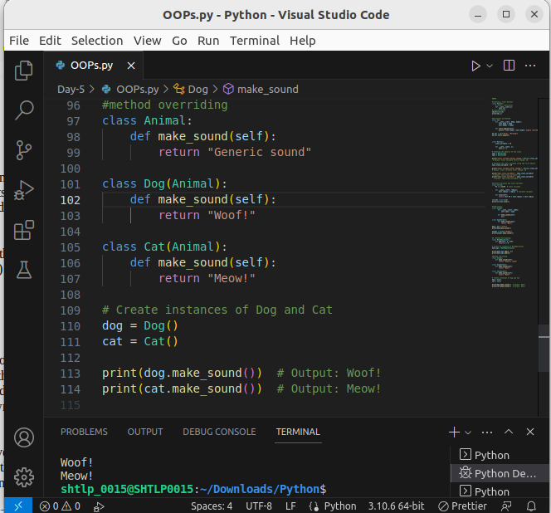

- Method Overloading in Python:
Python does not support method overloading in the traditional sense as some other languages like Java do, where multiple methods with the same name but different parameter lists can coexist in a class. In Python, defining multiple methods with the same name and different parameters will simply overwrite the previous method definition, and only the last definition will be retained.

- However, Python allows for a form of method overloading by using default arguments. You can define a method with default arguments and then call it with different numbers of arguments. Depending on the number of arguments passed during the method call, different versions of the method can be executed.

- Example of Method Overloading with Default Arguments:
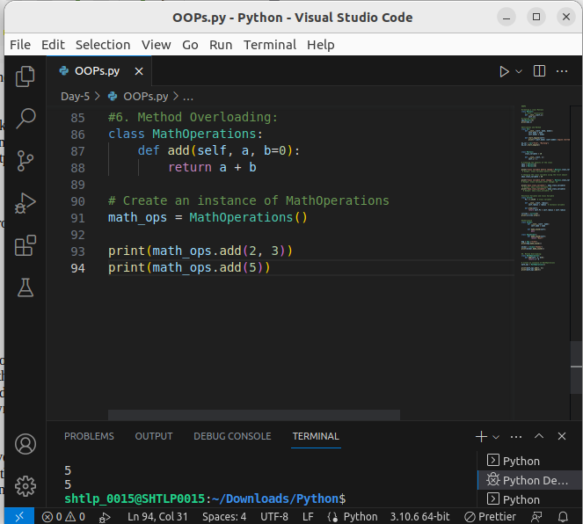

2. Operator Overloading

Operator overloading is a feature in Python that allows you to define and customize the behavior of operators for user-defined objects. Python provides special methods (dunder methods) that can be implemented in classes to handle specific operators. These methods start and end with double underscores (__). For example, the __add__ method is used to overload the + operator, and the __sub__ method is used to overload the - operator.

Example of Operator Overloading :

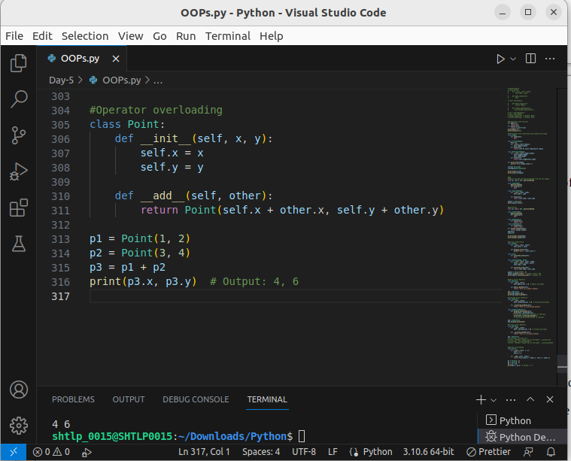

3. Encapsulation:

- Encapsulation restricts access to certain methods and attributes to prevent direct manipulation from outside the class.
Encapsulation is one of the four fundamental principles of object-oriented programming (OOP) and is used to restrict access to certain attributes and methods of an object. It ensures that the internal implementation details of a class are hidden from the outside world, and access to the object's state and behavior is controlled through specific methods. This concept is often referred to as "data hiding" as it allows the object to manage its own internal state.

In Python, encapsulation is achieved using naming conventions, where attributes or methods that are intended to be private or not directly accessible outside the class are prefixed with double underscores (__). This makes these attributes and methods "private" and prevents them from being accessed directly from outside the class.

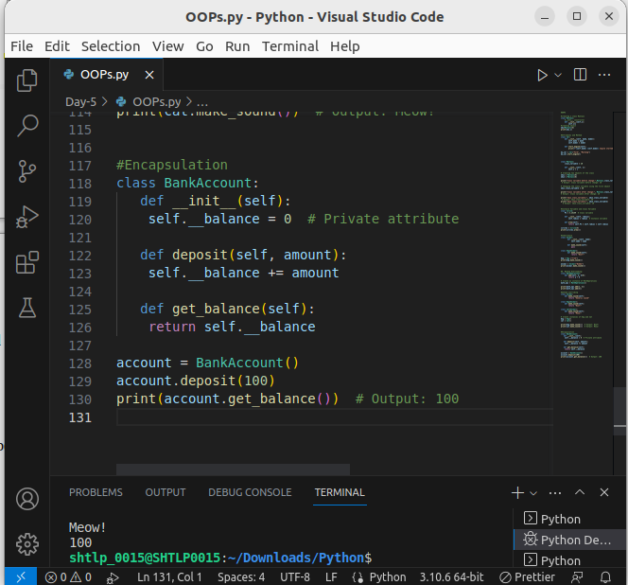
.
In the code above, we have a class BankAccount, representing a simple bank account. The class has a private attribute __balance, which is intended to store the account balance. By prefixing the attribute with double underscores (__), we make it private, so it cannot be accessed directly from outside the class.

The class also has two methods:

def deposit(self, amount):: This method allows deposits to be made into the bank account. It takes an amount as a parameter and increases the balance (__balance) by that amount.

def get_balance(self):: This method returns the current account balance (__balance). It allows external code to access the balance indirectly, without direct access to the private attribute.

Finally, we create an instance of the BankAccount class named account, make a deposit of 100 units, and then print the account balance:

4. Polymorphism:
- Polymorphism allows objects of different classes to be treated as objects of a common superclass.

Polymorphism is one of the four fundamental principles of object-oriented programming (OOP). It allows objects of different classes to be treated as objects of a common superclass, providing a consistent interface for different classes. In other words, different classes can implement the same method name, but they can have different implementations of that method. When calling a method on an object, the appropriate version of the method is executed based on the actual type of the object.

EX:1 :In this example, the add() function can handle both integer and string inputs and provide different behavior based on the types of arguments passed.

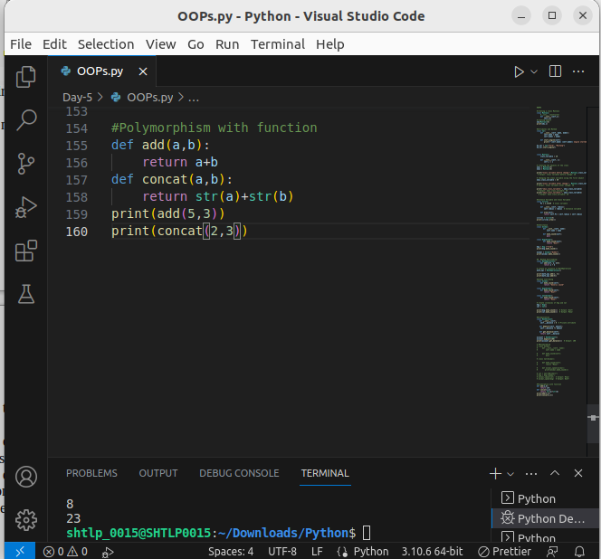

ex-2

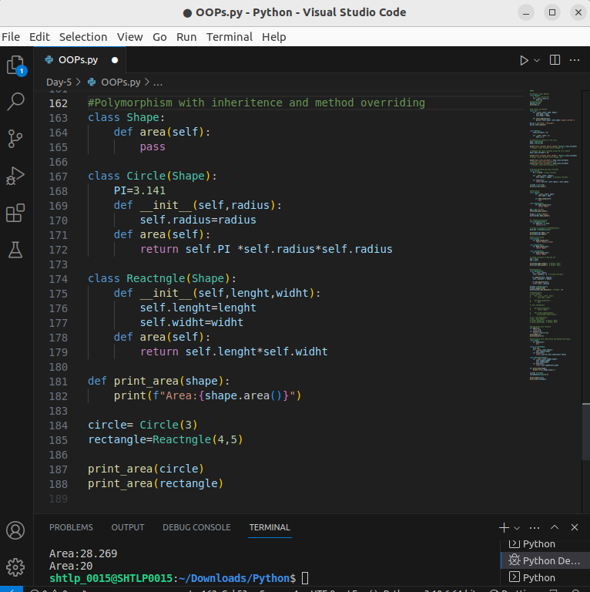

5. SELF PARAMETER :

In Python, the `self` parameter is a convention used to refer to the instance of the class. It is the first parameter of instance methods and is automatically passed when a method is called on an object. It allows the method to access and manipulate the object's attributes.

Example:

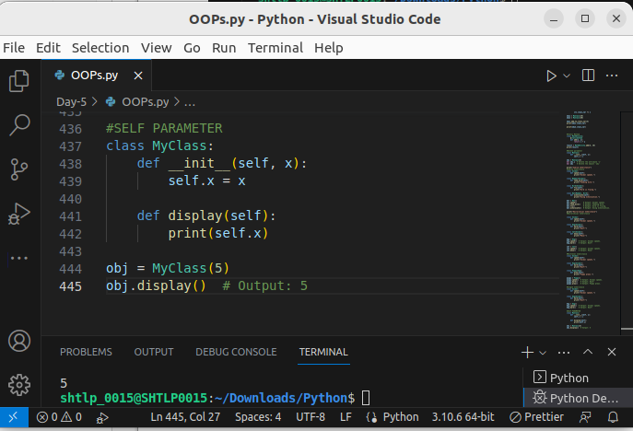
.

6. Decorators:

Decorators are a powerful feature in Python that allow you to modify or extend the behavior of functions or methods without changing their code. Decorators are denoted by the `@decorator_name` syntax and are applied above the function or method definition.

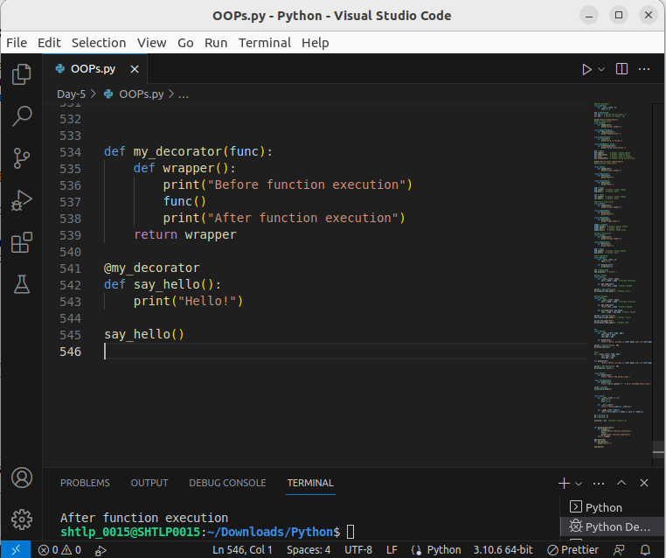

7.Getter Method:

A getter method, also known as an accessor method, is used to retrieve the value of a private attribute from a class.
It provides read-only access to the private attribute, allowing external code to retrieve its value but not modify it directly.
Typically, getter methods are named using the convention get_attribute, where attribute is the name of the private attribute.

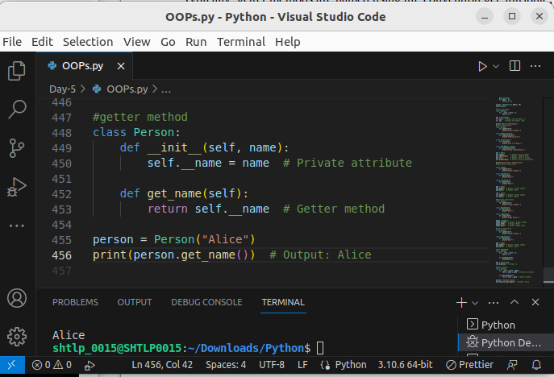

8. Setter Method:

A setter method, also known as a mutator method, is used to modify the value of a private attribute from a class.
It provides write-only access to the private attribute, allowing external code to set its value but not retrieve it directly.
Typically, setter methods are named using the convention set_attribute, where attribute is the name of the private attribute.

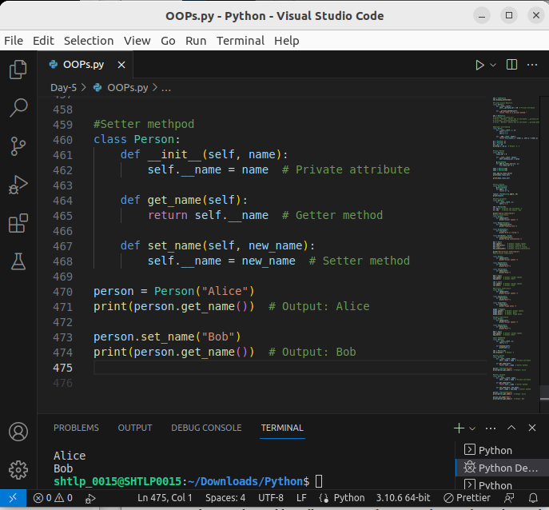
.

9. Abstraction:
- Abstraction focuses on showing relevant information to the outside world while hiding unnecessary details.

Abstraction is one of the fundamental principles of object-oriented programming (OOP) and is used to hide the implementation details of an object and only expose relevant features or functionalities to the outside world. It allows you to focus on what an object does rather than how it does it, making the code more manageable, modular, and easy to understand.

In Python, abstraction can be achieved through Abstract Base Classes (ABCs) or simply by using class methods, properties, and interfaces to provide a simplified view of an object's behavior.

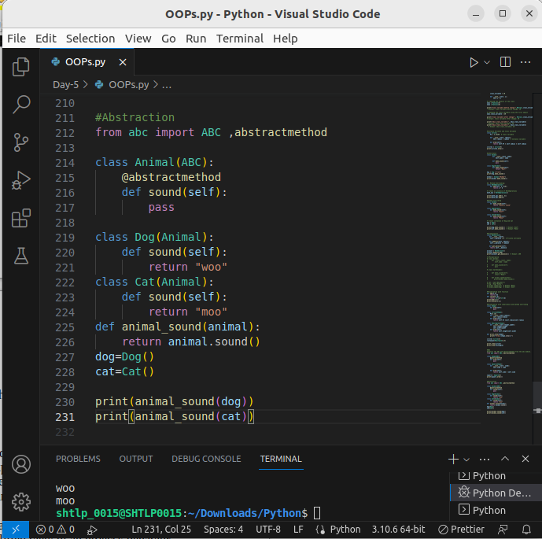

12. Abstract Base Classes (ABCs):
- ABCs define a common interface for its subclasses but cannot be instantiated themselves.

Abstract Base Classes are classes that cannot be instantiated directly and are used to define a common interface for their subclasses. They provide a way to enforce that specific methods must be implemented by their concrete subclasses.

To create an abstract base class in Python, we need to import the ABC (Abstract Base Class) and abstractmethod from the abc module. The abstractmethod decorator is used to mark methods as abstract, meaning they must be implemented in any concrete subclass.

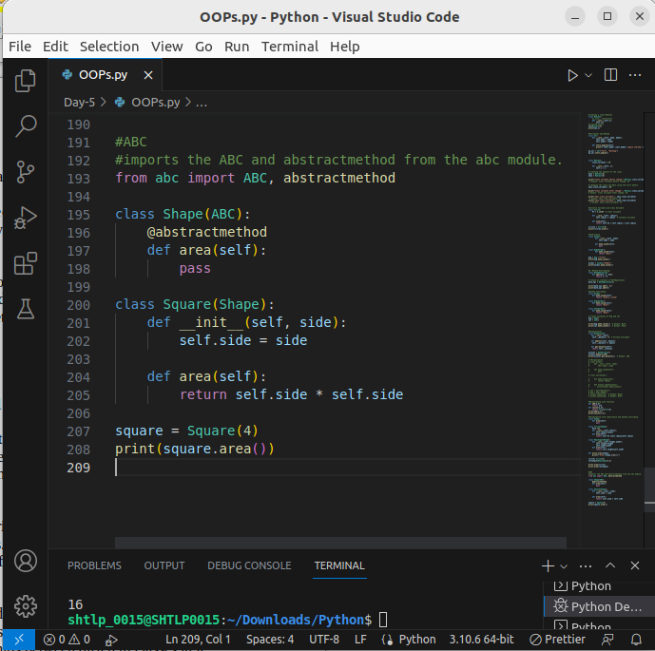

11.Advantage of using abs class:

Using Abstract Base Classes (ABCs) in Python has several advantages:

1. Enforcing Method Implementation: By defining abstract methods in an abstract base class, you can ensure that all the subclasses must implement those methods. This helps in providing a common interface and structure across all subclasses. It acts as a contract that forces the subclasses to adhere to certain behaviors.

2. Code Flexibility and Reusability: ABCs allow you to write code that operates on abstract classes and their methods, rather than on specific implementations. This makes your code more flexible and reusable since it can work with any concrete subclass that follows the interface defined by the abstract class.

3. Design Clarity: Abstract base classes provide a clear and explicit indication of what methods must be implemented in the subclasses. This makes the design and intent of the classes more transparent and helps in better understanding the relationships between different classes in a program.

4. Avoiding Unexpected Errors: Abstract methods act as placeholders, ensuring that any attempt to call an abstract method directly on the abstract base class will raise a `TypeError`. This prevents accidental misuse of the base class and helps avoid unexpected errors.

5. Documentation and Consistency: Using ABCs provides a clear and documented contract for subclasses, making it easier for other developers to understand and extend the codebase. It enforces a consistent structure and behavior among different subclasses, making the overall codebase more maintainable.

Built-in function

1. `dir()`:

`dir()` is a built-in Python function that returns a list of valid attributes for a specified object. It can be used on any object to get a list of all the attributes and methods available for that object, including the attributes and methods inherited from its classes.

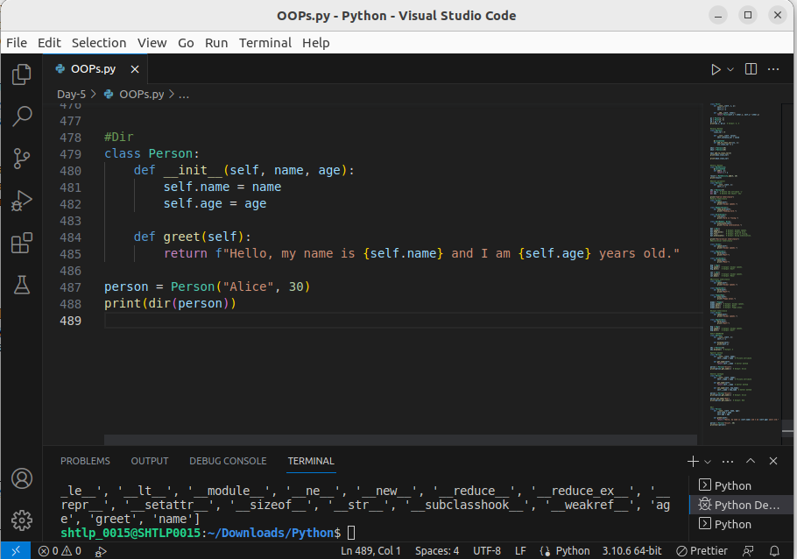

2. `__dict__`:

`__dict__` is a special attribute of an object that returns a dictionary containing the object's namespace. It includes all the attributes and their corresponding values defined for that object.

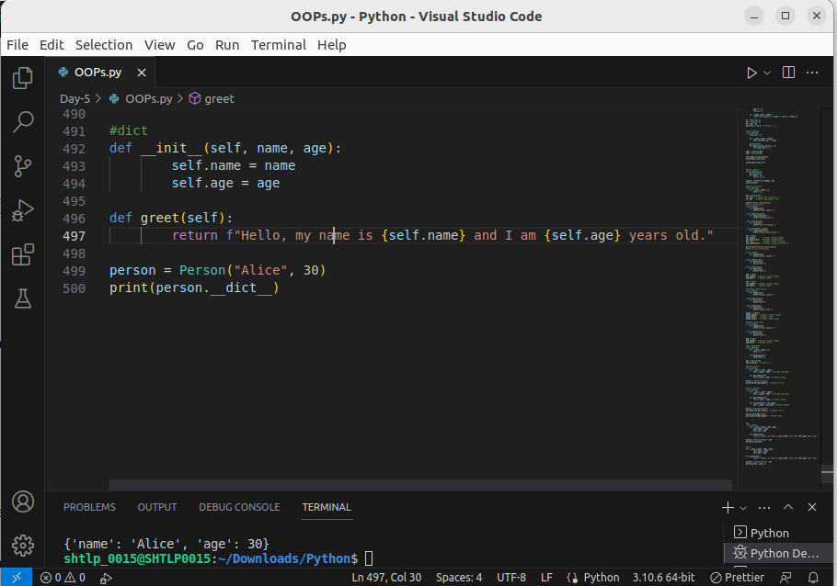

3 `super()` keyword:

`super()` is used in Python to call a method from the parent class. It is often used in the context of method overriding to call the method with the same name from the parent class. This allows you to extend the functionality of the parent class's method in the child class without completely replacing it.

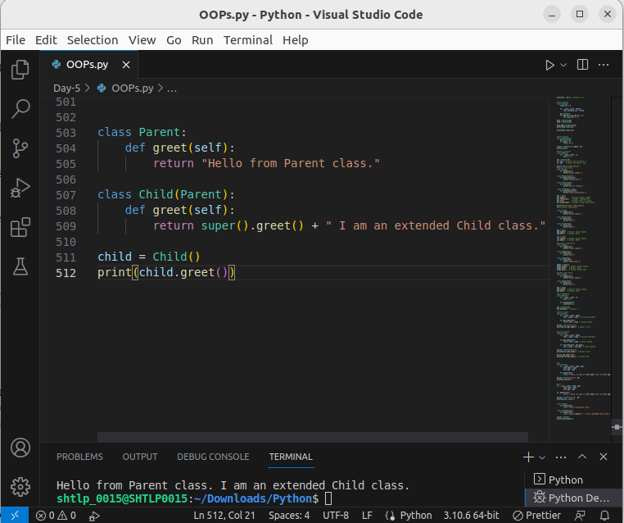
.

4. Dunder Methods:

Dunder methods (double underscore methods) are special methods in Python identified by their names enclosed in double underscores. They are also known as magic methods or special methods because they provide functionality to customize the behavior of classes and objects in various ways.

Some common dunder methods include `__init__` for object initialization, `__str__` for string representation, `__add__` for addition, `__eq__` for equality comparison, and many more.

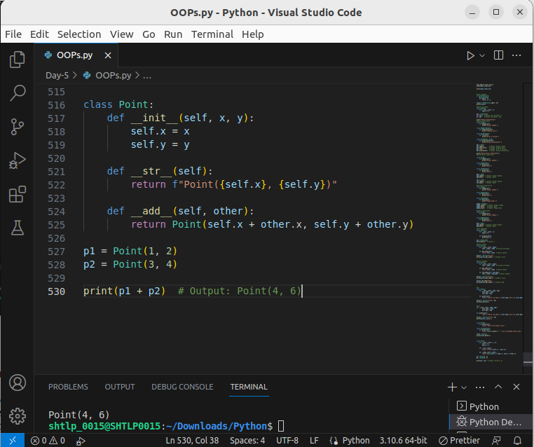

In this example, we have defined the `__init__`, `__str__`, and `__add__` dunder methods for the `Point` class to customize its behavior. The `__str__` method allows us to define how to represent the object as a string, and the `__add__` method enables us to add two `Point` objects together.

